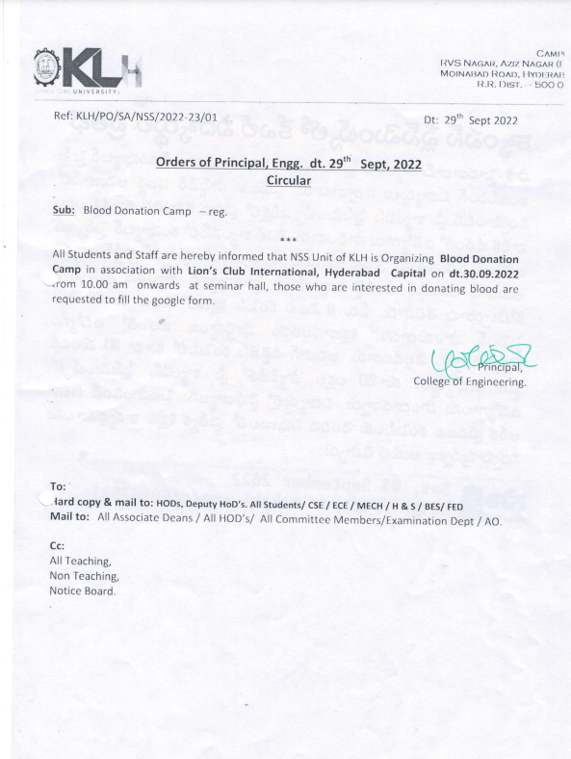



**Blood Donation 2022**

**Date of Event: 30-09-2022**

**Time: 10:00 am -12:00 pm**

**Location of Event: Activity Room**

**Number of Persons Attending: 135**

**Faculty Coordinator:** **Dr. Mardanpally Mallesh**

**Conducted By: National Service Scheme**

Today, i.e, 30-09-2022, the NSS unit of KL deemed to be University, Hyderabad has organized a blood donation camp in association with Lions Club, International Hyderabad Capital at 11.20 am in the Activity room.

The chief Dr. Sahul(MBBS, FIDM) and guest of honor Mr. Ratnam (senior technician camp organizer) members ofLions Club, International Hyderabad Capital graced the function. They were welcomed by giving saplings. Dr. M.P Mallesh, program officer, NSS unit, KL Hyderabad has briefed on the importance of blood donation in community service.

The blood donation was followed. As soon as the donors entered the hall first their weight was checked and a form was filled out including their information. First, they were checked by the doctor if they were eligible to give blood or not. The students of age above 18 years and weight above 45kgs were only permitted to donate blood. It was also ensured that the donor had a proper breakfast and other nutritional conditions were examined carefully before permitting blood donation. After check-ups only they were allowed to donate blood. The safe hemoglobin levels of female donors were ensured for blood donation. The donors were given fruits and nutritional drinks to boost their energy post-blood donation.

Not only students but even teachers came forward to donate blood.In this program, Dr. L. Koteshwar Rao – principal of KL College of Engineering, Dr.M.P Malesh NSS program officer, and AO Paparao attended the program.

Certificates were given to blood donors as appreciation for their contribution. It is pleasure to know that more than 100 students participated in this and made the event successful. As this blood will help hundreds of people’s life.





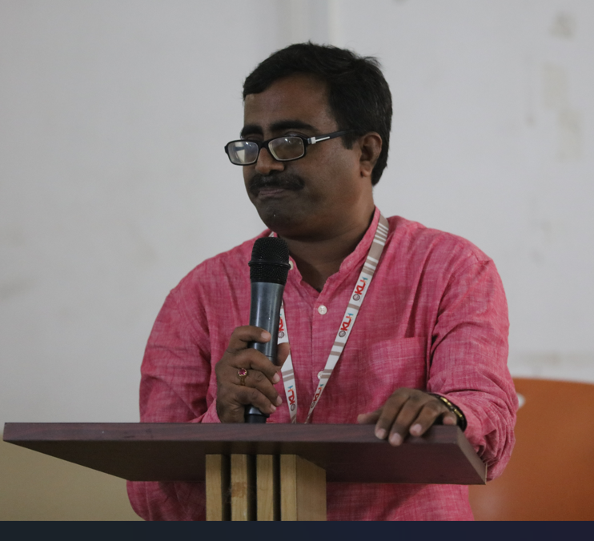

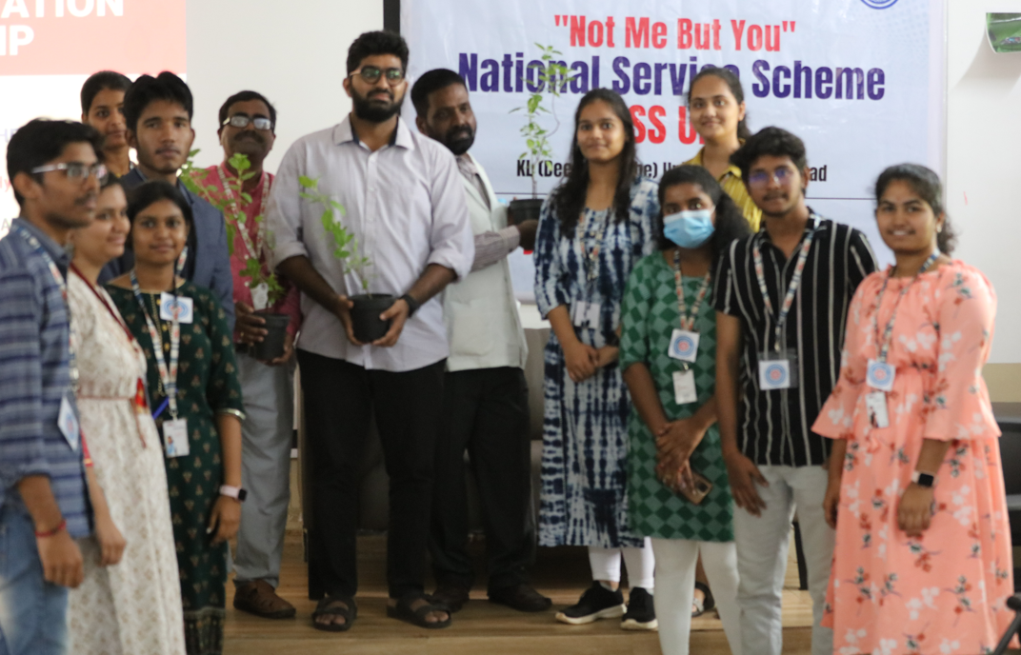

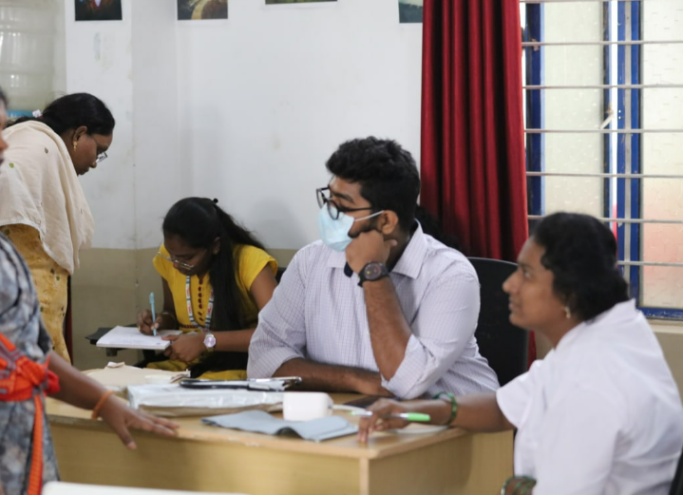

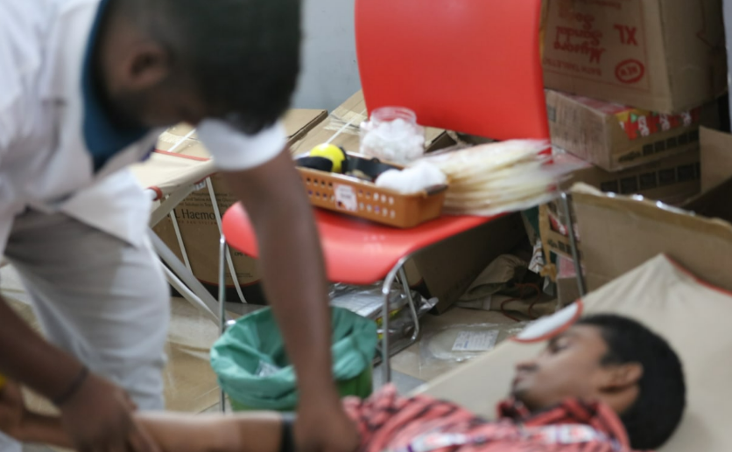

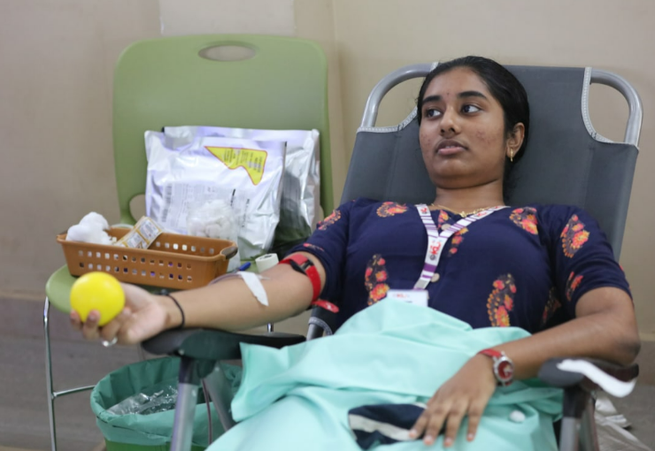

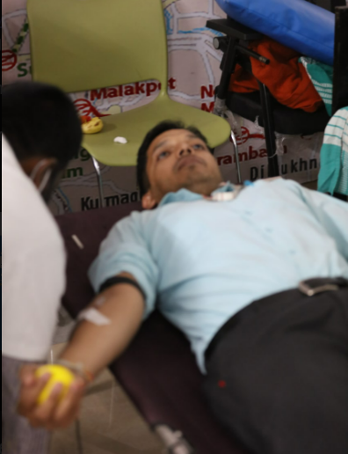

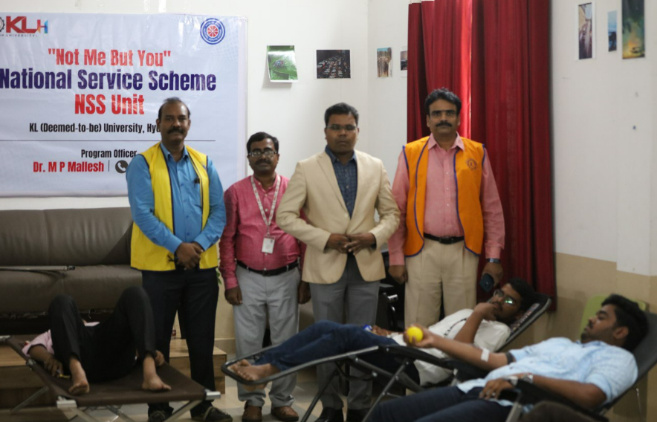

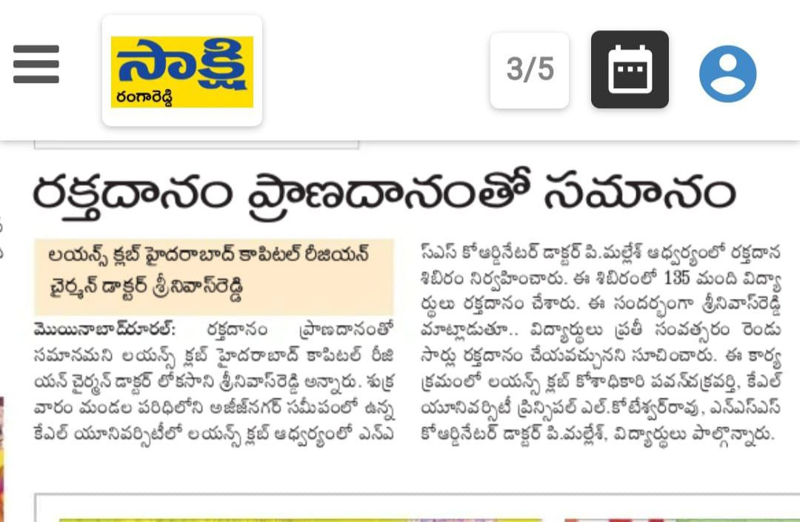

STUDENTS PARTICIPATION LIST

|  |  |  |  |
| --- | --- | --- | --- |
| **S.No** | **Name** | **B.Group** | **PH. NUMBER** |
| 1 | MOHAN.L | O+ve | 9010569259 |
| 2 | VENKATESH.P | O+ve | 7993286635 |
| 3 | GIRISH | A+ve | 6304169536 |
| 4 | Krishna | B+ve | 7075912306 |
| 5 | Sai laxmi | B+ve | 9392750596 |
| 6 | Manikanth | B+ve | 9391481335 |
| 7 | Karthik | A+ve | 9381107537 |
| 8 | Jashwanth | B+ve | 9550062092 |
| 9 | Sai | A+ve | 6305148115 |
| 10 | Vinay | O+ve | 8309239696 |
| 11 | Nikhith | A+ve | 9391272881 |
| 12 | Uday | O+ve | 6281124983 |
| 13 | Jashwanth | B+ve | 8688557088 |
| 14 | Rohit | O-Neg | 8125717612 |
| 15 | VAATSVA | O+ve | 9642829636 |
| 16 | RaKesh | B+ve | 9676408209 |
| 17 | Tarun | A+ve | 9063226133 |
| 18 | Sudharshan | AB+ve | 9675053840 |
| 19 | JAthiN | O+ve | 8008517310 |
| 20 | Vasundhara | O+ve | 8074594010 |
| 21 | Koushik | A+ve | 9346740446 |
| 22 | Abhites | AB+ve | 9392684342 |
| 23 | saketh | O+ve | 9949792646 |
| 24 | Hemanth | A+ve | 6302216070 |
| 25 | Karthik | O+ve | 9390745148 |
| 26 | SATHISH | B+ve | 9542250060 |
| 27 | Afroz | B+ve | 9100756443 |
| 28 | Nikhil | O+ve | 9100714907 |
| 29 | Abhilash | O+ve | 7702163575 |
| 30 | VASEEM | O+ve | 7893461190 |
| 31 | Siddarth | A+ve | 7981290017 |
| 32 | Sri | B+ve | 8309477216 |
| 33 | Jahnavi | A+ve | 8639552765 |
| 34 | VAMSHI | O+ve | 9391068456 |
| 35 | Sahil | O+ve | 7021091956 |
| 36 | Satya sai | O+ve | 8688812201 |
| 37 | Swaroop | O+ve | 7031580178 |
| 38 | Koushik | O+ve | 7569997609 |
| 39 | PAVAN KALYAN | O+ve | 9133553055 |
| 40 | koushik | O+ve | 6309558532 |
| 41 | Koushik | O+ve | 7075554714 |
| 42 | Likhik | O-Neg | 9492240011 |
| 43 | Suryanarayana | B+ve | 8328558481 |
| 44 | sai santosh | O+ve | 7981659937 |
| 45 | Nani | O+ve | 6303244682 |
| 46 | Vidatri | A+ve | 6304797597 |
| 47 | T. KRUTHIK REDDY | O+ve | 6302107460 |
| 48 | HARISH | O+ve | 9391716078 |
| 49 | VARSHINI | O+ve | 7075550669 |
| 50 | DHEERAJ | B+ve | 8978965973 |
| 51 | INDRA REDDY | B+ve | 9030896128 |
| 52 | SAI GANESH | A+ve | 7794892859 |
| 53 | SREE CHARAN | O+ve | 8897552565 |
| 54 | KOUSHIK | B+ve | 9392973173 |
| 55 | VISHWAR | B+ve | 7396439736 |
| 56 | VARSHITH.K | O+ve | 8074931187 |
| 57 | SANYI HARISH | O+ve | 9177922429 |
| 58 | B. VEGESH SAI | A+ve | 6301989290 |
| 59 | LOKESH.G | O+ve | 6303647062 |
| 60 | S. SHASHANTH REDDY | O+ve | 9390212776 |
| 61 | SHAAN.S | B+ve | 9866472089 |
| 62 | KARTHIK.L | B+ve | 7995081693 |
| 63 | VAISHNAVI | O+ve | 9676936220 |
| 64 | MAHESH.G | B+ve | 8688092789 |
| 65 | ABHIRAM | B+ve | 7032637045 |
| 66 | ROSHAN | O+ve | 9154410528 |
| 67 | KARTHIK.S | O+ve | 8179238127 |
| 68 | UDAY KIRAN.B | O+ve | 6300264265 |
| 69 | ABDUL SAMAD | B+ve | 8106961351 |
| 70 | PRAKESH | A+ve | 9603969459 |
| 71 | ANKUSH KUMAR | O+ve | 7013449185 |
| 72 | VIVEK.K | O+ve | 8008026477 |
| 73 | CHANDRA SHEKAR | B+ve | 9182370523 |
| 74 | SRI CHARAN | O+ve | 7816032450 |
| 75 | D. SHIVA RAJIV REDDY | A+ve | 9381051243 |
| 76 | N. SHASHIDAR | AB+ve | 7842518346 |
| 77 | NANDA.T | B-NEG | 8499991297 |
| 78 | VENU MADHAV | O+ve | 4981962604 |
| 79 | N.MANAS | O-Neg | 8328396789 |
| 80 | SIDDARTH.S | A+ve | 7893399590 |
| 81 | N. AKSHAY REDDY | B-NEG | 7075713191 |
| 82 | KISHOR.K | B+ve | 9533113221 |
| 83 | SAI DEEPAK.K | B+ve | 9912468655 |
| 84 | BHAVYA .M | O+ve | 9652036899 |
| 85 | KOSHIK | O+ve | 7981584209 |
| 86 | VENKATESH | O+ve | 9492850047 |
| 87 | SREE NITYA | B+ve | 8328433101 |
| 88 | ANIL KUMAR | B+ve | 8374913791 |
| 89 | K. AMRUTHA | A+ve | 9390271568 |
| 90 | ABIRAM.K | O+ve | 8328215749 |
| 91 | MADHUSAI | O+ve | 9347244599 |
| 92 | SUSHAS | O+ve | 9603411499 |
| 93 | DEEPAK | O+ve | 9701100551 |
| 94 | M. SAI SUBRAMANYAM | B+ve | 7893034575 |
| 95 | ANANYA.P | AB+ve | 7780442084 |
| 96 | HARIKA .V | B+ve | 8978036460 |
| 97 | LOKESH KUMAR | O+ve | 9490584418 |
| 98 | N. RAMINI | A+ve | 9246564364 |
| 99 | GEETHA SINGH | O+ve | 7680854848 |
| 100 | SHASHANK.B | B+ve | 9392960227 |
| 101 | SIDDARTH.HB | O+ve | 9353478857 |
| 102 | JEEVANI | O+ve | 9177644408 |
| 103 | LEELA RISHIKA.P | A+ve | 7386274321 |
| 104 | RAVITEJA.J | AB+ve | 7673980968 |
| 105 | VINAY.P | O+ve | 9652445842 |
| 106 | VAMSHI.B | O+ve | 9550722958 |
| 107 | SHAHANA | B+ve | 8978356636 |
| 108 | LIKHITHA | B+ve | 7036448368 |
| 109 | NARASIMHA.T | B+ve | 7893229688 |
| 110 | UJWAL.P | O+ve | 7013423314 |
| 111 | ASHWITH REDDY | B+ve | 9666577739 |
| 112 | LOKESH.M | AB+ve | 9398151146 |
| 113 | P. CHANDRA MOULI | O+ve | 9777593769 |
| 114 | RISHI KRISHNA | B+ve | 9618050011 |
| 115 | HEMANTH SRIATH | O-Neg | 9949036600 |
| 116 | NAGESH.D | A+ve | 6218082268 |
| 117 | DR. GIRIDHAR UNKUDE | O+ve | 7898104488 |
| 118 | G.SURAJ | B+ve | 8790346028 |
| 119 | SHIVA RAM | A+ve | 8790519989 |
| 120 | KARTHIK | O-Neg | 9182861140 |
| 121 | MOON BANERJEE | O+ve | 7999626421 |
| 122 | SRI CHARAN | B+ve | 7396421978 |
| 123 | SRIJAN.B | A+ve | 8019298500 |
| 124 | ASHWITHA.C | O+VE | 8309489104 |
| 125 | sunayan | A+ve | 9391271033 |
| 126 | charan | A+ve | 8121213043 |
| 127 | m. nishanth | O+ve | 7981885251 |
| 128 | a.varshith | A+ve | 7337334200 |
| 129 | dillep reddy | O-Neg | 9392370381 |
| 130 | akshith.m | O+ve | 8712710699 |
| 131 | manjunath.m | O+ve | 9347622694 |
| 132 | sujith reddy.m | B-NEG | 8008697227 |
| 133 | hitesh.m | A+ve | 9391761959 |
| 134 | bheeshma .k | AB+ve | 7993846880 |
| 135 | koushik.k | A+ve | 917715568 |
|  |  |  |  |
|  |  |  |  |
|  |  |  |  |
|  |  |  |  |
|  |  |  |  |
|  |  |  |  |
|  |  |  |  |
|  |  |  |  |
|  |  |  |  |
|  |  |  |  |
|  |  |  |  |
|  |  |  |  |
|  |  |  |  |
|  |  |  |  |
|  |  |  |  |
|  |  |  |  |
|  |  |  |  |
|  |  |  |  |
|  |  |  |  |
|  |  |  |  |